**A SOC Mini Project**

**Report**

**On**

**E-COMPUTER BOOK STORE**



|  |  |
| --- | --- |
|  | **Submitted By** |
| **Miss. K.MEGHANA** | **RegdNo:21B95A0503** |

**DEPARTMENT OF COMPUTER SCIENCE ENGINEERING**

**S.R.K.R ENGINEERING COLLEGE (A)**

**(Affiliated to JNTU, KAKINADA)**

**BHIMAVARAM-534204**

**(2021-2022)**

**DEPARTMENT OF COMPUTER SCIENCE AND ENGINEERING S.R.K.R. ENGINEERING COLLEGE BHIMAVARAM**



*CERTIFICATE*

This is to certify that this is a bonafide work on “**E-COMPUTER BOOK STORE**” and has been submitted by Miss.K.MEGHANA(**21B95A0503**), ,in partial fulfillment of the requirements for the award of the Degree of Bachelor of Technology in Computer Science and Engineering, during the academic year 2021-2022. The candidate worked right under my Supervision and guidance.

**Lecturers In-Charge** **Head of the Department**

**B L V SIVA RAMA KRISHNA** **Dr.V.Chandra Sekhar**

Assistant professor, Head of the Department,

Department of CSE, Department of CSE,

S.R.K.R. Engineering College, S.R.K.R.Engineering College,

Bhimavaram. Bhimavaram.

**ACKNOWLEDGEMENT**

I take immense pleasure in thanking **Dr. M.Jagapathi Raju ,** beloved principal of S.R.K.R Engineering College, Bhimavaram and **Dr.V.Chandra** **Shekar,** esteemed **Head of the Department** (C.S.E), for having permittedme to carry out this software engineering mini project work.

I wish to express my deep sense of gratitude especially to my project Guide**, Sri. B L V SIVA RAMA KRISHNA, Assistant Professor,** for his able guidance and useful suggestions, which helped me in completing the project work, in time.

Finally, yet importantly, I would like to express my heart full thanks to my beloved parents for their blessings, my friends/classmates for their help and wishes for the successful completion of this project.

K.MEGHANA

(21B95A0503)

**TABLE OF CONTENTS**

**S.No** **CONTENTS** **PageNo**

1. ABSTRACT 05

2. MODULES 06

3. SOFTWARE REQUIREMENTS 06

4. HARDWARE REQUIREMENTS 06

5. TECHNICAL STACK 06

6. SAMPLE CODE 07

7. SCREENSHOTS 16

8. LAB PROGRAMS 24

1. **ABSTRACT**

The main objective of the project is to create an online book store that allows users to search and purchase a Computer Books online based on title, author and subject. The books are displayed in a tabular format and the user can order their books online through credit card payment. Using this Website the user can purchase a book online instead of going out to a book store and wasting time.

**DISCRIPTION**

E-COMPUTER BOOK STORE is an online web application where the customer can purchase books online. Firstly, the customer must login using his account details or new customers can set up an account very quickly. After the customer has logged in, through a web browser the customers can search for a book by its title or author, later can add to the shopping cart and finally purchase using credit card transaction. They should give the details of their name, contact number and shipping address. The books are divided into many categories based on subject like Software, Database, Programming, and Algorithms etc. The Online Book Store Website provides customers with online shopping through a web browser.

The Administrator will have additional functionalities when compared to the common user. He can add, delete and update the book details, book categories, member information and also confirm a placed order.

**2.MODULES**

Login Page

Registration Page

Admin Page

Home Page

Categories Page

Transaction Page

About Page

Contact Page

Logout

**3. SOFTWARE REQUIREMNET**

|  |  |  |
| --- | --- | --- |
| **Number** | **Description** | **Type** |
| 1 | Operating System | Windows XP / Windows |
| 2 | IDE | Visual Code |
| 3 | Browser | Google Chrome |

**4. HARDWARE REQUIREMNET**

|  |  |
| --- | --- |
| Number | Description |
| 1 | PC with 250 GB or more Hard disk. |
| 2 | PC with 8 GB RAM. |
| 3 | PC with Intel and Above processor |
| 4 | PC With 256GB SSD |

**5. TECHNICAL STACK**

HTML

CSS

**6. SAMPLE CODE**

<!DOCTYPE html>

<html lang="en">

<head>

<meta charset="UTF-8">

<meta http-equiv="X-UA-Compatible" content="IE=edge">

<meta name="viewport" content="width=device-width, initial-scale=1.0">

<title>Document</title>

<!-- font awesome cdn link -->

<link rel="stylesheet"href="https://cdnjs.cloudflare.com/ajax/libs/font-awesome/5.15.4/css/all.min.css">

<link rel="stylesheet" href="style.css">

</head>

<body>

<section class="featured" id="Algorithms">

<div class="books">

<div class="box">

<div class="image">

<img src="Images/Algorithm1.jpg" alt="Algotithms">

</div>

<div class="content">

<h3>Algorithms Illuminted: The Basics: 1 </h3>

<span>by Tim Roughgarden </span>

<div class="feedback">

<i class="fas fa-star checked"></i>

<i class="fas fa-star checked"></i>

<i class="fas fa-star checked"></i>

<i class="fas fa-star checked"></i>

<i class="fas fa-star checked"></i>

</div>

<div class="price">₹699.00</div>

<div class="buttons">

<div><button class="btn" onclick="alert('SUCCESSFULLY ADDED TO CART')"><a>Add to Cart</a></button></div>

<div><button class="btn"><a href="Purchase.html" tagret="content">Buy Now</a></button></div>

</div>

</div>

</div>

<div class="box">

<div class="image">

<img src="Images/Algorithm2.jpg" alt="Algorithms">

</div>

<div class="content">

<h3>DESIGN AND ANALYSIS OF ALGORITHEMS</h3>

<span>by S. Sridhar </span>

<div class="feedback">

<i class="fas fa-star checked"></i>

<i class="fas fa-star checked"></i>

<i class="fas fa-star checked"></i>

<i class="fas fa-star checked"></i>

<i class="far fa-star checked"></i>

</div>

<div class="price">₹288.00</div>

<div class="buttons">

<div><button class="btn" onclick="alert('SUCCESSFULLY ADDED TO CART')"><a>Add to Cart</a></button></div>

<div><button class="btn">

<a href="Purchase.html" tagret="content">Buy Now</a></button></div></div>

</div>

</div>

<div class="box">

<div class="image">

<img src="Images/Algorithm3.jpg" alt="Algorithms">

</div>

<div class="content">

<h3>Fundamentals of Computer Algorithms</h3>

<span>by Sahni Horowitz </span>

<div class="feedback">

<i class="fas fa-star checked"></i>

<i class="fas fa-star checked"></i>

<i class="fas fa-star checked"></i>

<i class="fas fa-star checked"></i>

<i class="far fa-star checked"></i>

</div>

<div class="price">₹1,857.00</div>

<div class="buttons">

<div><button class="btn" onclick="alert('SUCCESSFULLY ADDED TO CART')"><a>Add to Cart</a></button></div>

<div><button class="btn"><a href="Purchase.html" tagret="content">Buy Now</a></button></div>

</div>

</div>

</div>

<div class="box">

<div class="image">

<img src="Images/Algorithm4.jpg" alt="Data Structures">

</div>

<div class="content">

<h3>Algorithm Design:Foumdation & Analysis Of Internet</h3>

<span>by Michael T. Goodrich</span>

<div class="feedback">

<i class="fas fa-star checked"></i>

<i class="fas fa-star checked"></i>

<i class="fas fa-star checked"></i>

<i class="fas fa-star checked"></i>

<i class="far fa-star checked"></i>

</div>

<div class="price">₹554.00</div>

<div class="buttons">

<div><button class="btn" onclick="alert('SUCCESSFULLY ADDED TO CART')"><a>Add to Cart</a></button></div>

<div><button class="btn">

<a href="Purchase.html" tagret="content">Buy Now</a></button></div></div>

</div>

</div>

<div class="box">

<div class="image">

<img src="Images/Datastructures1.jpg" alt="Data structures">

</div>

<div class="content">

<h3>Data Structures Through C In Depth</h3>

<span>by Michael T. Goodrich</span>

<div class="feedback">

<i class="fas fa-star checked"></i>

<i class="fas fa-star checked"></i>

<i class="fas fa-star checked"></i>

<i class="fas fa-star checked"></i>

<i class="far fa-star checked"></i>

</div>

<div class="price">₹360.00</div>

<div class="buttons">

<div><button class="btn" onclick="alert('SUCCESSFULLY ADDED TO CART')"><a>Add to Cart</a></button></div>

<div><button class="btn"><a href="Purchase.html" tagret="content">Buy Now</a></button></div>

</div>

</div>

</div>

<div class="box">

<div class="image">

<img src="Images/Datastructures2.jpg" alt="Data structures">

</div>

<div class="content">

<h3>Data Structures and Algorithms using C</h3>

<span>by R. S. Salaria</span>

<div class="feedback">

<i class="fas fa-star checked"></i>

<i class="fas fa-star checked"></i>

<i class="fas fa-star checked"></i>

<i class="fas fa-star checked"></i>

<i class="far fa-star checked"></i>

</div>

<div class="price">₹349.00</div>

<div class="buttons">

<div><button class="btn" onclick="alert('SUCCESSFULLY ADDED TO CART')"><a>Add to Cart</a></button></div>

<div><button class="btn"><a href="Purchase.html" tagret="content">Buy Now</a></button></div>

</div>

</div>

</div>

<div class="box">

<div class="image">

<img src="Images/Datastructures3.jpg" alt="Data structures">

</div>

<div class="content">

<h3>Data Structures&Algorithems using java</h3>

<span>by Michael T. Goodrich</span>

<div class="feedback">

<i class="fas fa-star checked"></i>

<i class="fas fa-star checked"></i>

<i class="fas fa-star checked"></i>

<i class="fas fa-star checked"></i>

<i class="far fa-star checked"></i>

</div>

<div class="price">₹554.00</div>

<div class="buttons">

<div><button class="btn" onclick="alert('SUCCESSFULLY ADDED TO CART')"><a>Add to Cart</a></button></div>

<div><button class="btn"><a href="Purchase.html" tagret="content">Buy Now</a></button></div>

</div>

</div>

</div>

<div class="box">

<div class="image">

<img src="Images/Datastructures1.jpg" alt="Data structures">

</div>

<div class="content">

<h3>Data Structures&Algorithms with Python </h3>

<span>by Kent D. Lee </span>

<div class="feedback">

<i class="fas fa-star checked"></i>

<i class="fas fa-star checked"></i>

<i class="fas fa-star checked"></i>

<i class="fas fa-star checked"></i>

<i class="far fa-star checked"></i>

</div>

<div class="price">₹782.00</div>

<div class="buttons">

<div><button class="btn" onclick="alert('SUCCESSFULLY ADDED TO CART')"><a>Add to Cart</a></button></div>

<div><button class="btn"><a href="Purchase.html" tagret="content">Buy Now</a></button></div>

</div>

</div>

</div>

<div class="box">

<div class="image">

<img src="Images/Datastructures4.jpg" alt="Data structures">

</div>

<div class="content">

<h3>Data Structures&Algorithms with Python </h3>

<span>by Kent D. Lee </span>

<div class="feedback">

<i class="fas fa-star checked"></i>

<i class="fas fa-star checked"></i>

<i class="fas fa-star checked"></i>

<i class="fas fa-star checked"></i>

<i class="far fa-star checked"></i>

</div>

<div class="price">₹782.00</div>

<div class="buttons">

<div><button class="btn" onclick="alert('SUCCESSFULLY ADDED TO CART')"><a>Add to Cart</a></button></div>

<div><button class="btn"><a href="Purchase.html" tagret="content">Buy Now</a></button></div>

</div>

</div>

</div>

<div class="box">

<div class="image">

<img src="Images/Datastructures3.jpg" alt="Data structures">

</div>

<div class="content">

<h3>Data Structures&Algorithms with Python </h3>

<span>by Kent D. Lee </span>

<div class="feedback">

<i class="fas fa-star checked"></i>

<i class="fas fa-star checked"></i>

<i class="fas fa-star checked"></i>

<i class="fas fa-star checked"></i>

<i class="far fa-star checked"></i>

</div>

<div class="price">₹782.00</div>

<div class="buttons">

<div><button class="btn" onclick="alert('SUCCESSFULLY ADDED TO CART')"><a>Add to Cart</a></button></div>

<div><button class="btn"><a href="Purchase.html" tagret="content">Buy Now</a></button></div>

</div>

</div>

</div>

</div>

</section>

<footer class="footer">

<div class="footer-container">

<div class="item">

<h3>About Us</h3>

<!-- <p>Find a new world at your fingertips with our wide selection of books online at E-Computer Book Store. Our online bookstore features the best computer books from bestselling authors, so you can click on categories to browse top computer books. You can find many computer books online that teach Various Computer Programming languages such as c, c++,JavaScript, Basic Internet, Basics About computers,Web Development and whatnot. Find the perfect book for your next read from the book experts at E-Computer Book Store.</p> -->

<p>E-Computer Book Store is online bookstore where we provide the best computer books from bestselling authors. Here You can find many computer books online that teach Various Computer Programming languages such as c,c++,JavaScript, Basic Internet and whatnot</p>

</div>

<div class="item" >

<h3>Get In Touch</h3>

<div class="icons" style="text-align: center;">

<div class="IconDis"><i class="fas fa-map-marker-alt"></i>Flat-no: s3,Mehar Nagar,Kakinada</div>

<div class="IconDis"><i class="fas fa-phone-alt"></i>9912550076</div>

<div class="IconDis"><i class="fas fa-envelope"></i>meghanaapt@gmail.com</div>

</div>

</div>

<div class="item">

<h3>Follow us</h3>

<center><div class="icons" style="margin-top: 20px;">

<i class="fab fa-whatsapp" style="font-size: 30px;color:white;background-color: green;border-radius: 50%;cursor: pointer;"></i>

<i class="fab fa-facebook" style="font-size: 30px;color:white;background-color: rgb(14, 81, 158);border-radius: 50%;cursor: pointer;"></i>

<i class="fab fa-instagram-square" style="font-size: 30px;color:white;background-color: rgb(211, 39, 96);border-radius: 50%;cursor: pointer;"></i>

<i class="fab fa-twitter-square"style="font-size: 30px;color:white;background-color:rgb(14, 81, 158);border-radius: 50%;cursor: pointer;"></i>

</div></center>

</div>

</div>

<div class="copyright">

<p>&copy; Copyright.<a href="Home.html" target="content">E-ComputerBooksStore</a></p>

</div>

</footer>

</body>

</html>

**7. SCREENSHOT**

**1. Login Page**

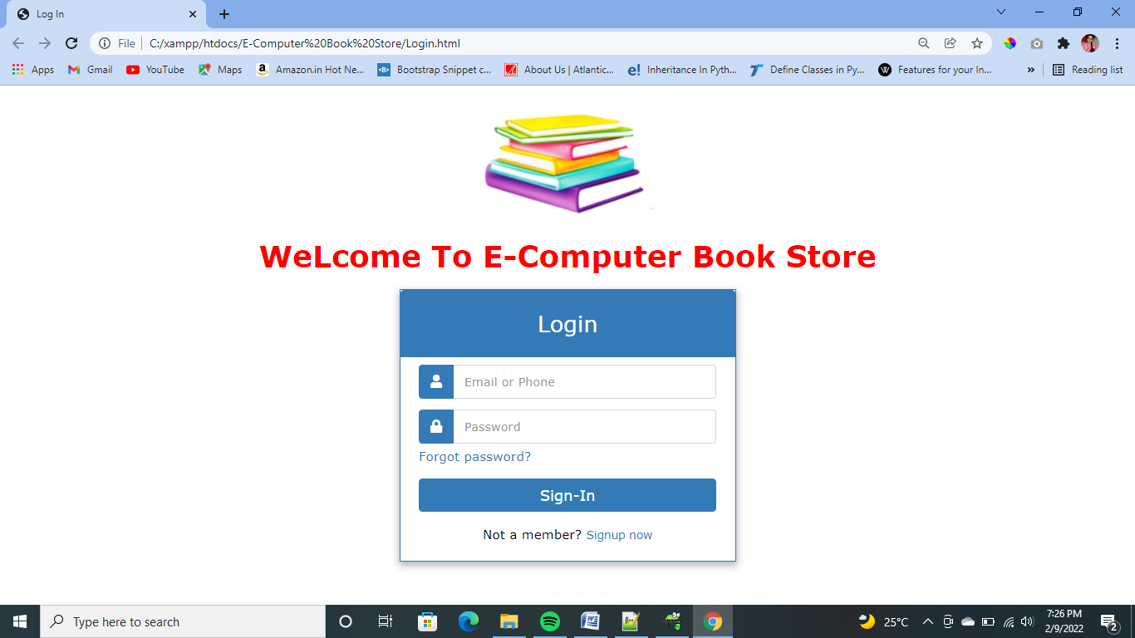

**2. Registration Page**

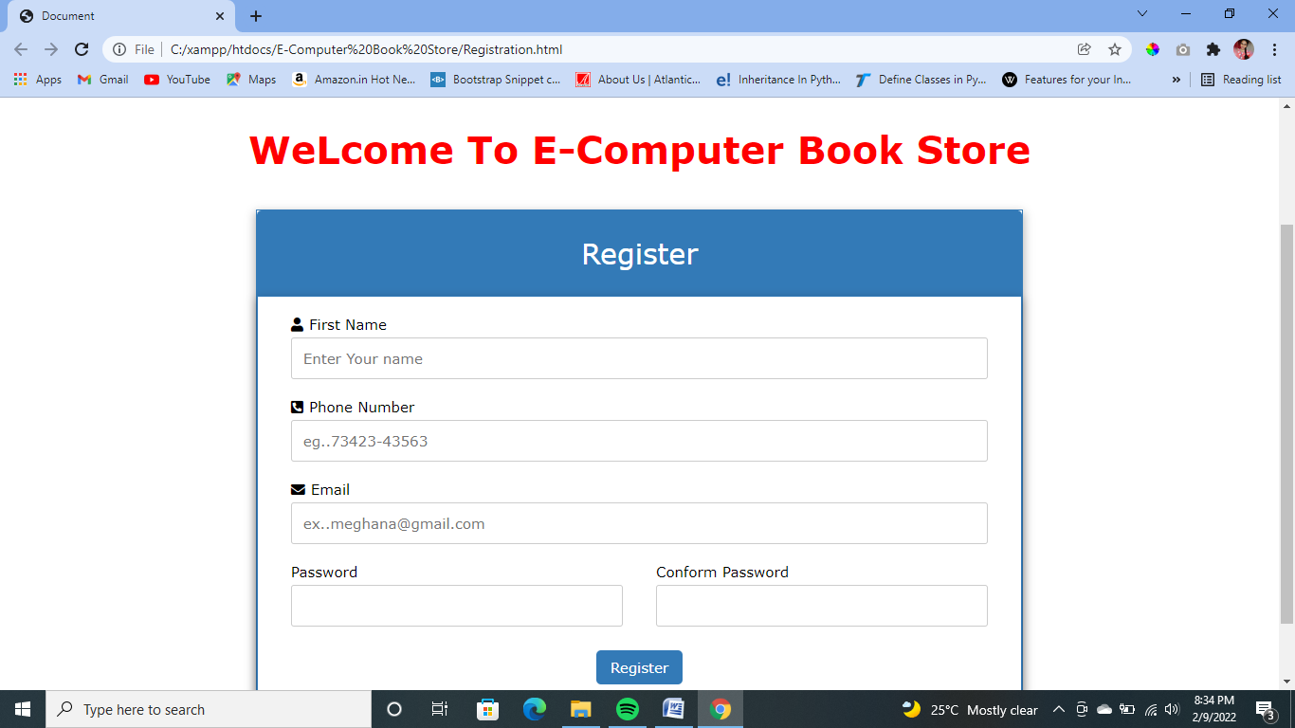

**3.Admin Page**

**3.1 Admin Login**

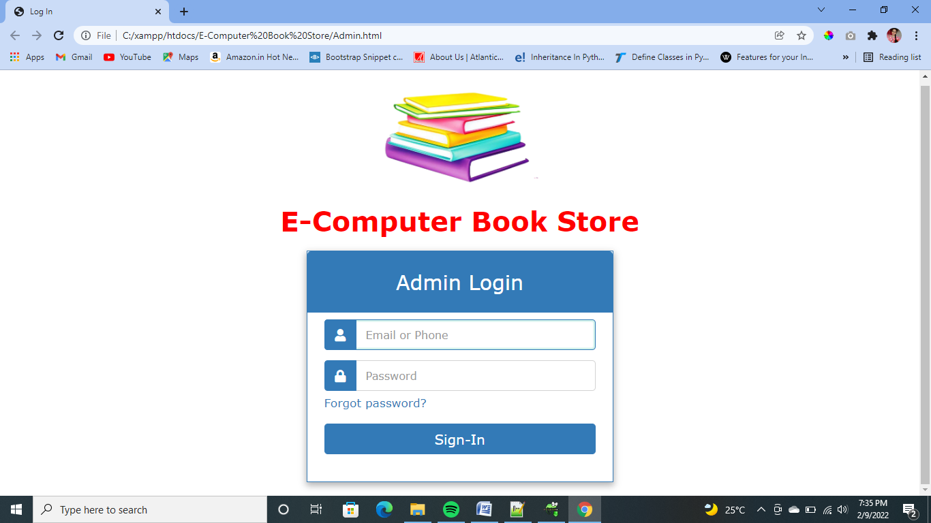

**3.2 Add Book Page**

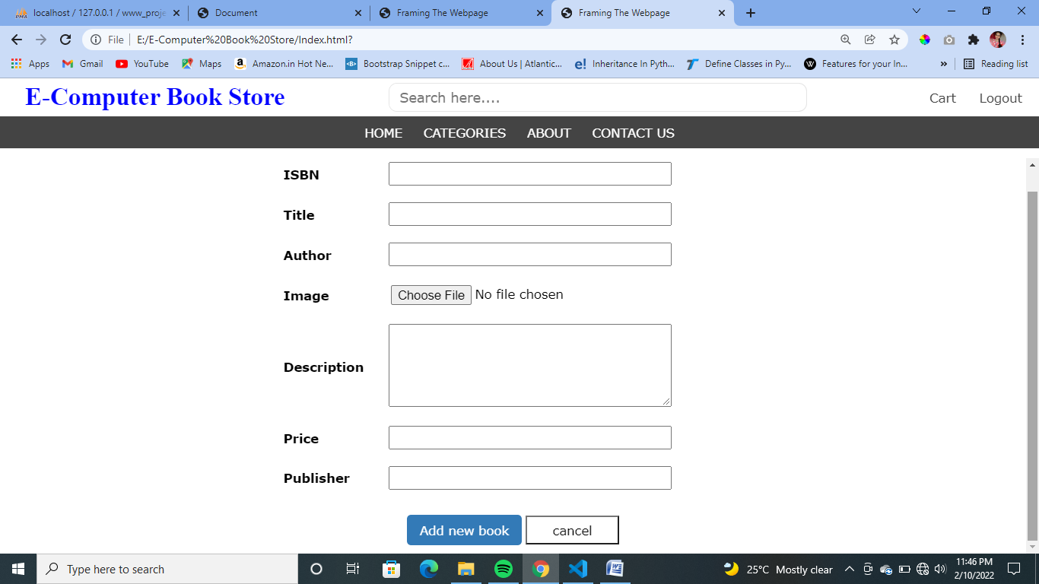

**4. Home Page**



**5. Categories Page**

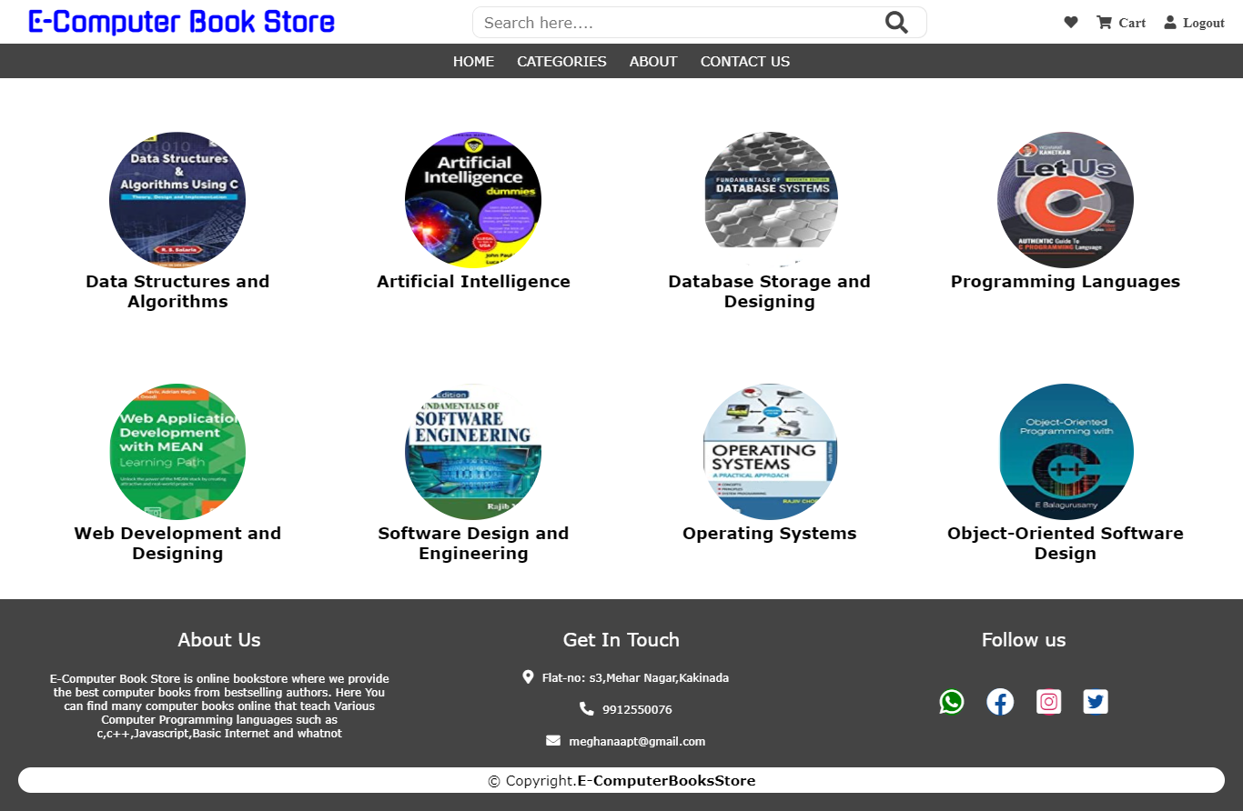

**5.1 Data Structures and Algorithms Books**

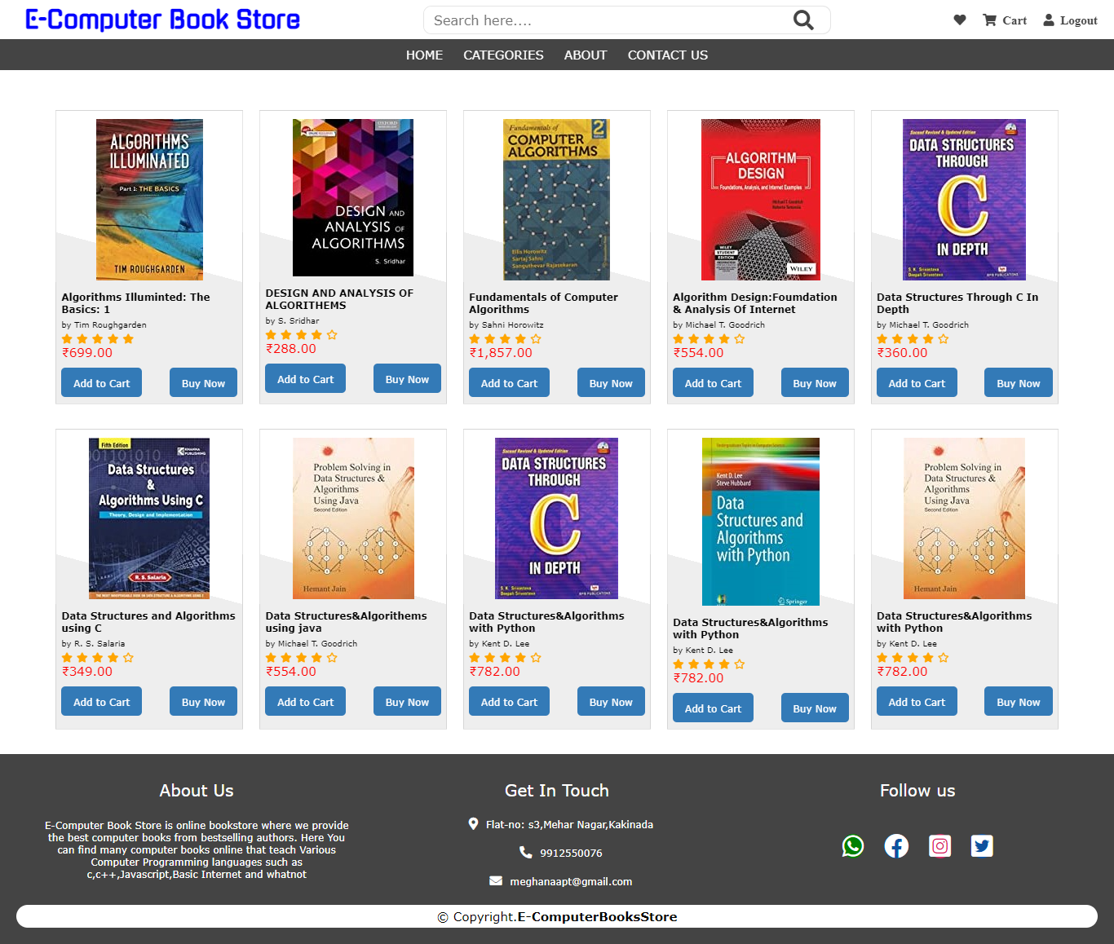

**5.2 Programming Languages**

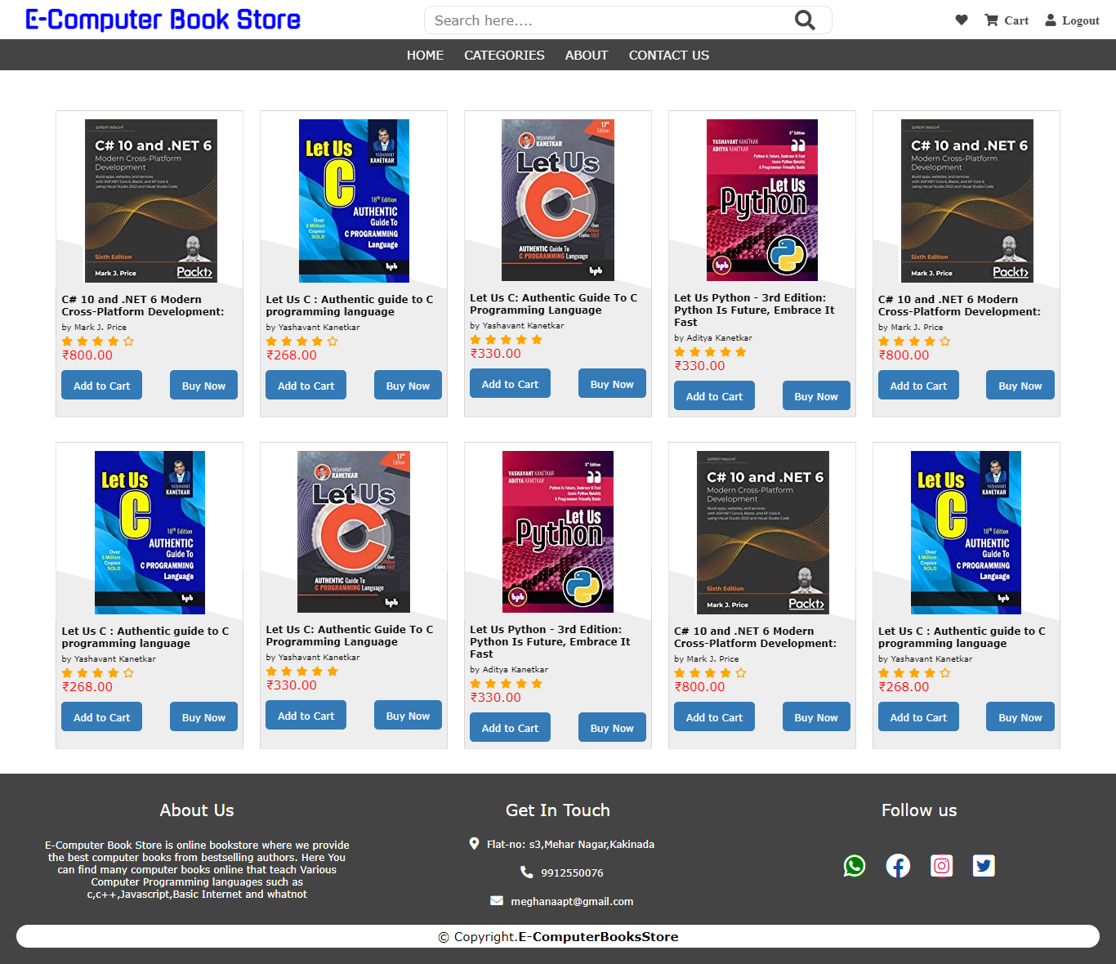

**5.3 Web Development and Designing**

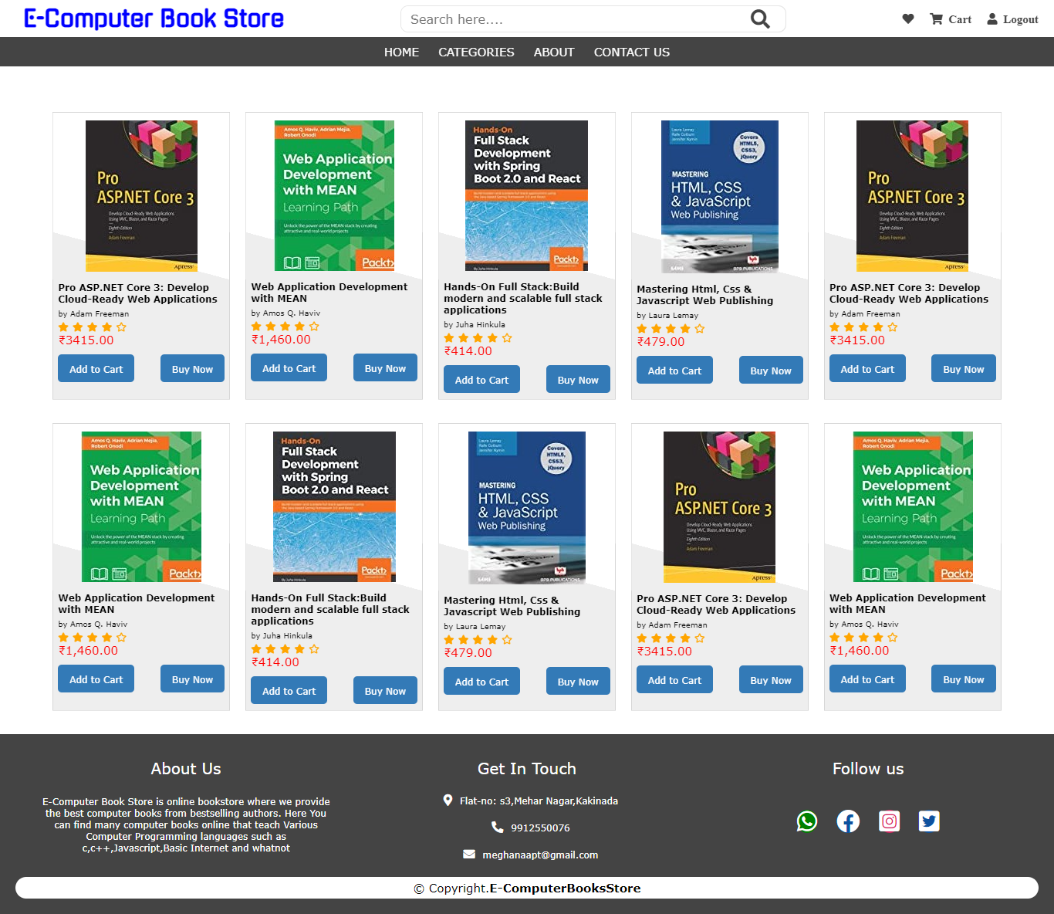

**6. Transaction Page**

**6.1 Delivery Address form**

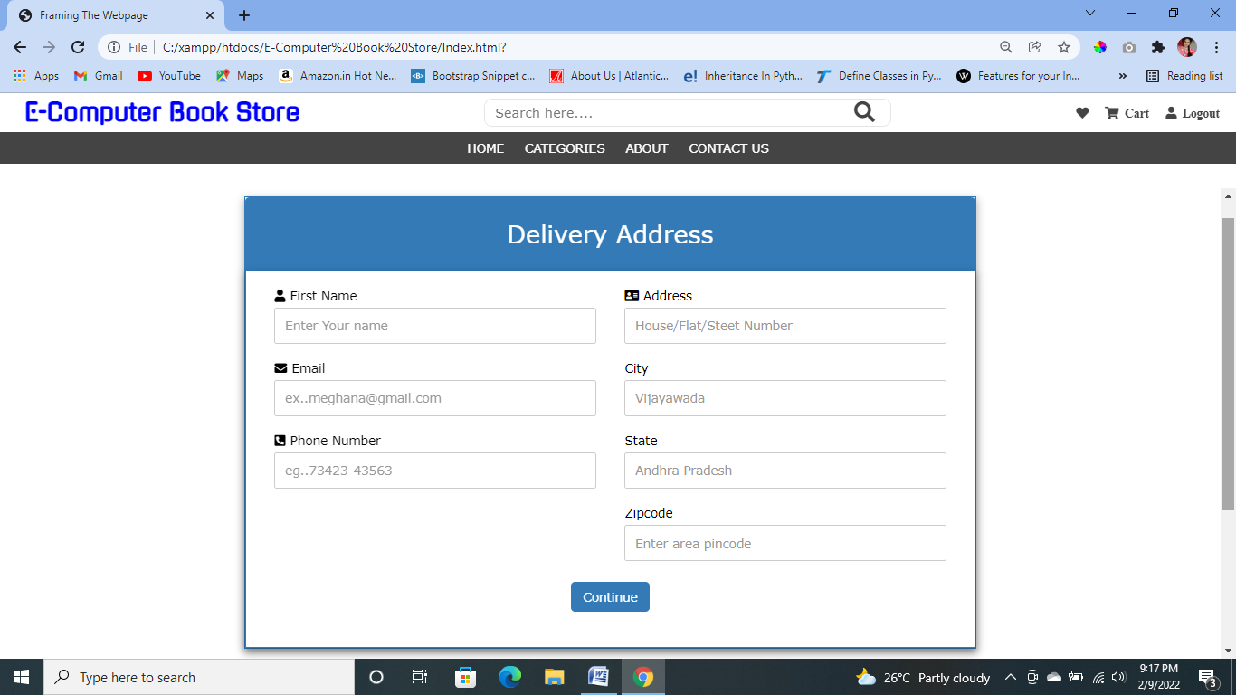

**6.2 Payment Method**

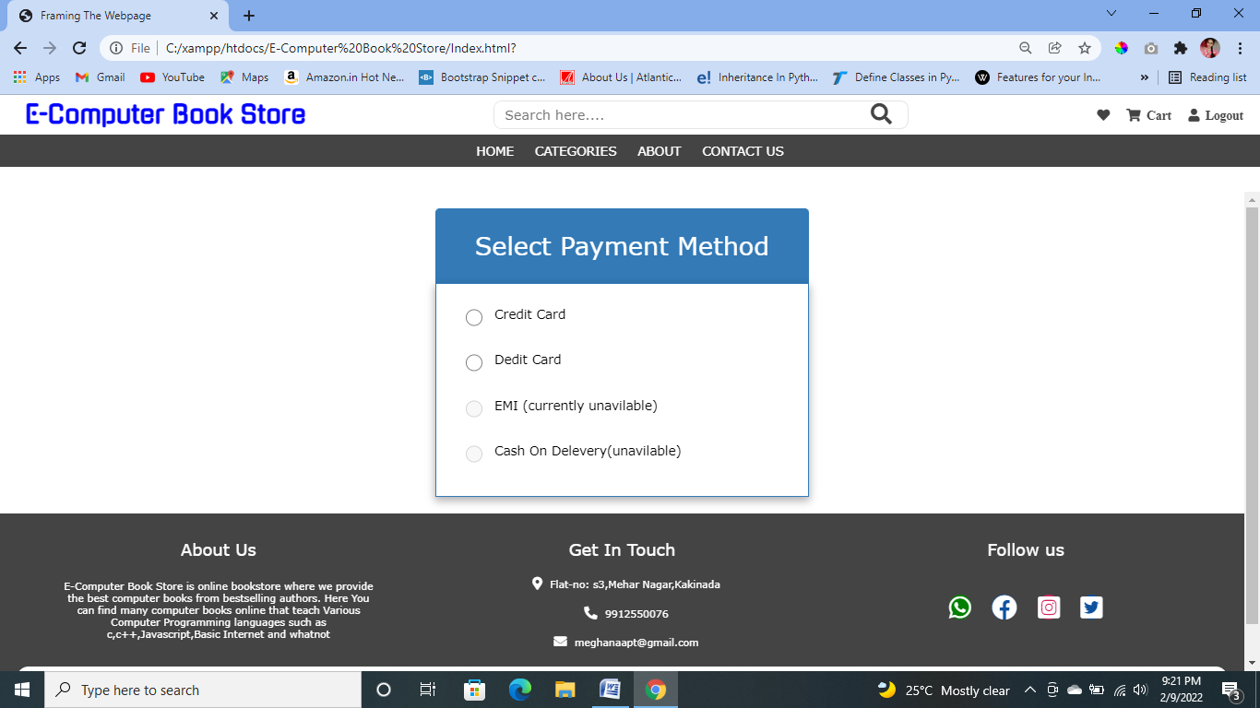

**6.3 Card Payment**

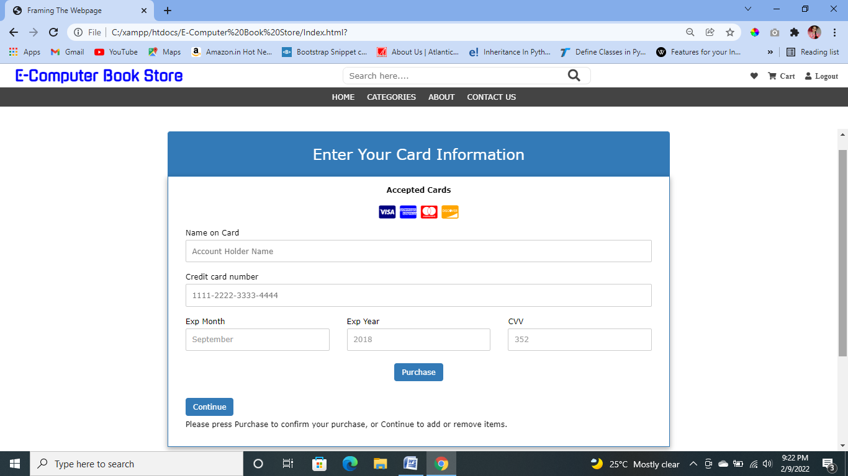

**7. About Page**

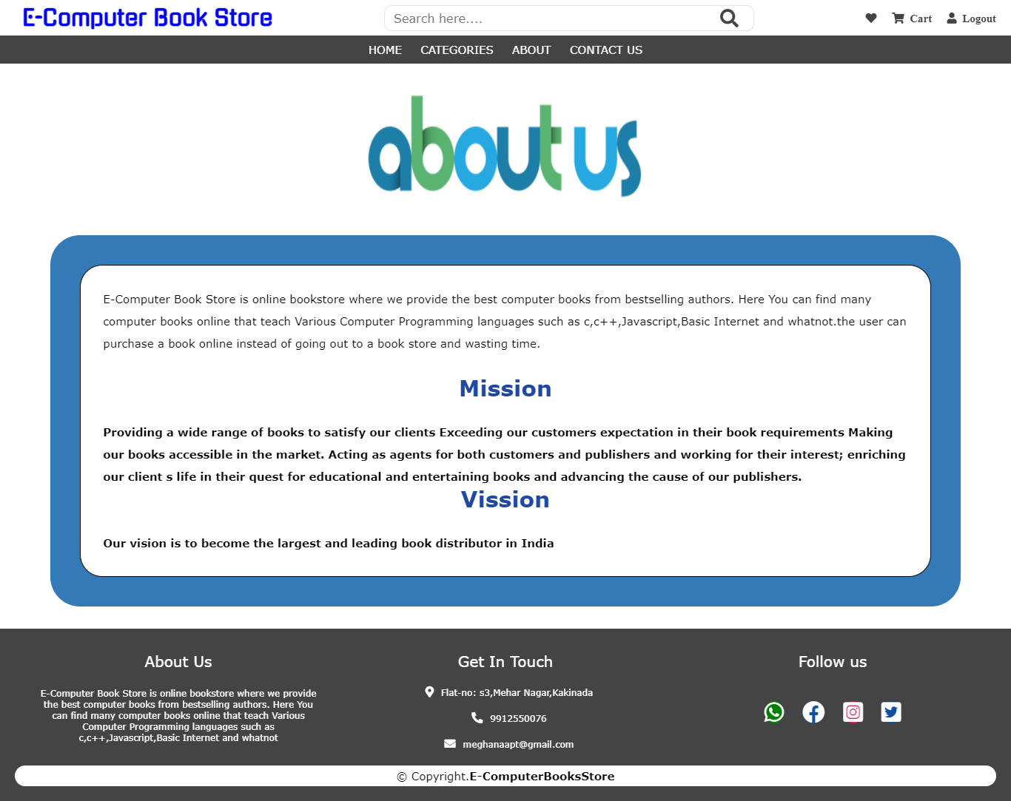

**8. Contact Page**

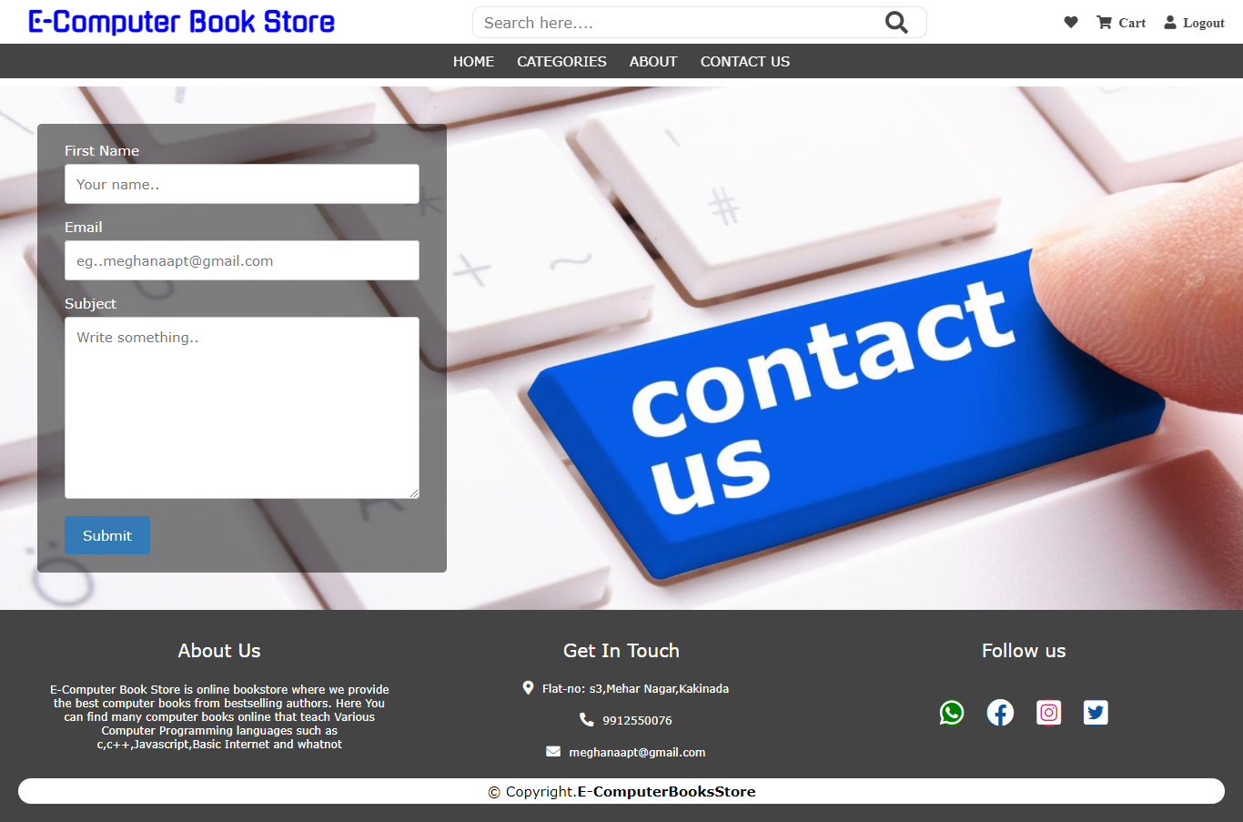

**8. Lab Programs**

1. **Create your profile page i.e. educational details, Hobbies, Achievement, My Ideals etc using all basic tags in HTML.**

**Source code:**

<!dOCTYPE html>

<html>

<head><title>Resume</title></head>

<style>

h3{

border: 3px solid #9EB8E7;

border-radius:10px;

background-color: #9EB8E7;

font-size:13px;

}

h1{

text-align: center;

font-size: 30px;

}

.border{

border: 2px double black;

width: 750px;

height: 950px;

padding:0px 10px;

margin: auto; /*To align div block in center*/

}

.Qualification{

width:750px;

}

.Qualification td,th{

border:1px solid black;

}

</style>

<body>

<div class="border">

<h1>kAKARLA MEGHANA</h1>

<div class="main"><img src="myprofile.jpg" alt="Profile" height=150px width=150px style="padding-right:6px;border-radius:20px;" align="right"></img>

<div style="width: 68%;">

<table cellspacing="2px" cellpadding="1px">

<tr><td>Phone no:</td><td>9912550076</td></tr>

<tr><td>Email Id:</td><td>meghanaapt@gmail.com</td></tr>

<tr><td valign="top">Address:</td>

<td>H-no: 1-56,</br>Krishna District,</br>Andhra Pradesh,</br>India,</br>521157</td></tr>

</table></div></div>

<h3>CAREER OBJECTIVES</h3>

<p>To make use of my interpersonal skills to achieve goals of a company that focuses on customer satisfaction and customer experience.</p>

<h3>QUALIFICATION DETAILS</h3>

<table style="border:1px solid black" class="Qualification">

<tr><th>Qualification</th><th>College/Institute</th><th>Place</th><th>Branch</th><th>Year</th>

<th>Aggregate</th></tr>

<tr><td>B.Tech</td>

<td>SRKR Institute Of Technology</td>

<td>Bhimavaram</td><td>CSE</td><td>2021-till date</td><td>-----</td></tr>

<tr><td>Polytechnic</td>

<td>Andhara Polytechnic</td>

<td>Kakinada</td>

<td>CSE</td>

<td>2018-2021</td>

<td>93.17%</td></tr>

<tr><td>SSC</td>

<td>Assisi English Medium High School</td>

<td>Pamarru</td><td>---</td><td>2017-2018</td><td>95%</td></tr></table>

<h3>ACHIEVEMENTS</h3>

<ul>

<li>I Got 34 rank in engineering common entrance test</li>

<li>I got 93% in polytechnic and stood class 1st</li>

<li>I got 10,000 rank in Polycet Entrace Exam state wide</li>

<li>I Got 10.0 GPA in SSC Board Exam</li>

<li>Received Prathiba Award For Academic Excellence in SSC by The Government of Andhra Pradesh</li></ul>

<h3>SKILLS</h3>

<ul>

<li>Quick Leaner</li>

<li>Programming Languages: C,JAVA

<li>Web Development: HTML,CSS,PHP,MYSQL DATABASE</li>

<li>Package: Windows 10,Microsoft Office 2007</li></ul>

<h3>HOBBIES</h3>

<ul>

<li>Singing Songs And Listening Music</li>

<li>Drawing</li>

<li>Knowing Intresting facts</li></ul>

<h3>STRENGHTS</h3>

<ul> <li>Self Motivation</li></ul>

</div>

</body>

</html>

**Output:**

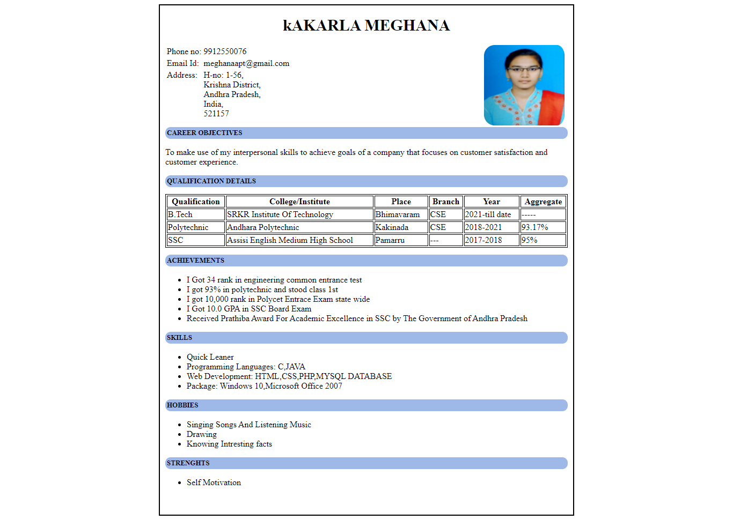

1. **Write an HTML code to illustrate the usage of the following:**
   * **Ordered List**
   * **Unordered List**
   * **Definition List**

**Source Code:**

<!DOCTYPE html>

<html>

<head><title>GeeksforGeeks</title></head>

<body>

<h2>Unordered List</h2>

<h5>List of available courses</h5>

<ul>

<li>Data Structures & Algorithm</li>

<li>Web Technology</li>

<li>Aptitude & Logical Reasoning</li>

<li>Programming Languages</li>

</ul>

<h2>Ordered List</h2>

<h5>Data Structures topics</h5>

<ol>

<li>Array</li>

<li>Linked List</li>

<li>Stacks</li>

<li>Queues</li>

<li>Trees</li>

<li>Graphs</li>

</ol>

<h2>Definition List</h2>

<dl>

<dt>Array</dt>

<dd>An array is a collection of items stored at contiguous memory locations. </dd>

<dt>Linked List</dt>

<dd>A linked list is a sequence of data structures, which are connected together via links</dd>

<dt>Stacks</dt>

<dd>Stack is a linear data structure which follows a particular order in which the operations are performed. </dd>

<dt>Queues</dt>

<dd>A Queue is a linear structure which follows a particular order in which the operations are performed.</dd>

</dl>

</body>

</html>

**Output:**

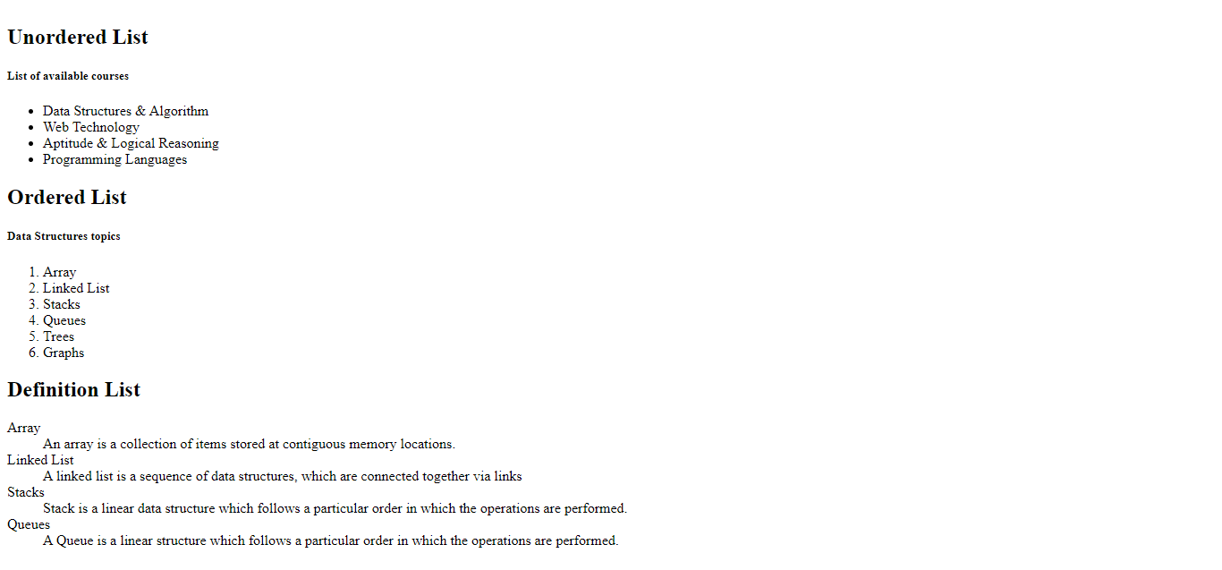

1. **Write an HTML code to create a Home page having three links: About Us, Our**

**Services and Contact Us. Create separate web pages for the three links.**

**Source Code:**

**Our Services Page**

<!DOCTYPE html>

<html lang="en">

<head>

<meta charset="UTF-8">

<meta http-equiv="X-UA-Compatible" content="IE=edge">

<meta name="viewport" content="width=device-width, initial-scale=1.0">

<title>Document</title>

</head>

<style>

h3{

text-align: center;

cursor: pointer;

}

td{

text-align: center;

}

</style>

<link href="Style.css" rel="stylesheet">

<body>

<center><img src="LOGO.jpg">

<h4>WELCOME TO Tutorials POINT</h4></center>

</div>

<div class="navbar">

<a href="#">Our Services</a>

<a href="About Us.html">About us</a>

<a href="Contact.html">Contact us</a>

</div>

<div class="border">

<table cellpadding="3px" cellspacing="40px" >

<tr><td><img src="Web1.jpg"><h3>Fullstack Web Developement</h3></td>

<td><img src="Mysql1.jpg"><h3>MYSQL Technology Pack</h3></td>

<td><img src="Python.png"><h3>Complete Python Pack</h3></td>

<td><img src="java.jpg"><h3>Java Core Developement</h3></td></tr>

<tr><td><img src="Angular1.jpg"><h3>Angular 8 Full Stack Developemnt</h3></td>

<td><img src="ML1.jpg"><h3>Machine Learning</h3></td>

<td><img src="Bitcoin.png"><h3>Bitcoins</h3></td>

<td><img src="Block.jpg"><h3>Blockchain</h3></td></tr></table></div>

</body>

</html>

**About Page:**

<!DOCTYPE html>

<html lang="en">

<head>

<meta charset="UTF-8">

<meta http-equiv="X-UA-Compatible" content="IE=edge">

<meta name="viewport" content="width=device-width, initial-scale=1.0">

<title>Document</title>

</head>

<link href="Style.css" rel="stylesheet">

<style>

h3{

text-align: center;

font-size: 30px;

}

h5{

text-align: center;

font-size: 20px;

background-color: rgb(212, 211, 211);

}

p{

font-size: 15px;

line-height: 2rem;

}

.border{

border: 2px solid black;

padding: 20px;

margin-top:20px;

border-radius: 3rem;

}

</style>

<body>

<body>

<center><img src="LOGO.jpg"></center>

<div class="navbar">

<a href="Home.html">Our Services</a>

<a href="#">About us</a>

<a href="Contact.html">Contact us</a>

</div>

<div class="border">

<h3>About Company</h3><br/>

<p>Tutorials Point originated from the idea that there exists a class of

readers who respond better to online content and prefer to learn new

skills at their own pace from the comforts of their drawing rooms.</p>

<p>The journey commenced with a single tutorial on HTML in 2006 and elated by the response it generated, we worked our way to adding fresh tutorials to our repository which now proudly flaunts a wealth of tutorials and allied articles on topics

ranging from programming languages to web designing to academics and much more.</p>

<h5>40 million readers read 100 million pages every month</h5><br/>

<p>Our Text Library Content and resources are freely available and we prefer to keep it that way

to encourage our readers acquire as many skills as they would like to. We don't force our readers to

sign up with us or submit their details either to use our Free Text Tutorials Library. No preconditions and no impediments

, Just Simply Easy Learning!</p>

<p>We have established a <b>Digital Content Marketplace</b> to sell Video Courses and eBooks at a very nominal cost.

You will have to register with us to avail these premium services.</p>

<h5>Mission</h5><br/>

<p>Our mission is to deliver <b>Simply Easy Learning</b> with clear, crisp, and to-the-point content on a wide range of technical and non-technical subjects without any preconditions and impediments.</p>

</div>

</body>

</html>

**Contact Page:**

<!DOCTYPE html>

<html lang="en">

<head>

<meta charset="UTF-8">

<meta http-equiv="X-UA-Compatible" content="IE=edge">

<meta name="viewport" content="width=device-width, initial-scale=1.0">

<title>Document</title>

</head>

<style>

input[type=text],input[type=email], select, textarea {

width: 100%;

padding: 12px;

border: 1px solid #ccc;

border-radius: 4px;

box-sizing: border-box;

margin-top: 6px;

margin-bottom: 16px;

resize: vertical;

}

input[type=submit] {

background-color:green;

color: white;

padding: 12px 20px;

border: none;

border-radius: 4px;

cursor: pointer;

}

.Contactcontainer {

border-radius: 5px;

width:450px;

padding: 20px 30px;

margin: 3% auto;

}

</style>

<link href="Style.css" rel="stylesheet">

<body>

<body>

<center><img src="LOGO.jpg"></center>

<div class="navbar">

<a href="Home.html">Our Services</a>

<a href="About Us.html">About us</a>

<a href="#">Contact us</a>

</div>

<div class="Contactcontainer">

<form action="#" autocomplete="off">

<label for="fname">First Name</label>

<input type="text" id="fname" name="firstname" placeholder="Your name.." required>

<label for="email">Email</label>

<input type="email" id="lname" name="email" placeholder="eg..meghanaapt@gmail.com" required>

<label for="subject">Subject</label>

<textarea id="subject" name="subject" placeholder="Write something.." style="height:200px" required></textarea>

<input type="submit" value="Submit">

</form>

</div>

</body>

</html>

**Style.css:**

*{

font-family: Verdana, Geneva, Tahoma, sans-serif;

margin: 0%;

padding: 0%;

}

.navbar{

margin-top: 1px;

background-color: rgb(27, 134, 27);

padding: 10px;

text-align: center;

}

.navbar a{

color:white;

font-size: 20px;

font-family: Georgia, 'Times New Roman', Times, serif;

padding: 9px 15px;

text-decoration: none;

}

.navbar a:hover{

background-color: white;

color: green;

}

.border{

border: 2px solid white;

width:70%;

height:500px;

margin:auto;

padding: 10px;

}

img{

width: 150px;

height:150px;

cursor: pointer;

}

h4{

font-size: 40px;

}

**OutPut:**

**Services Page**

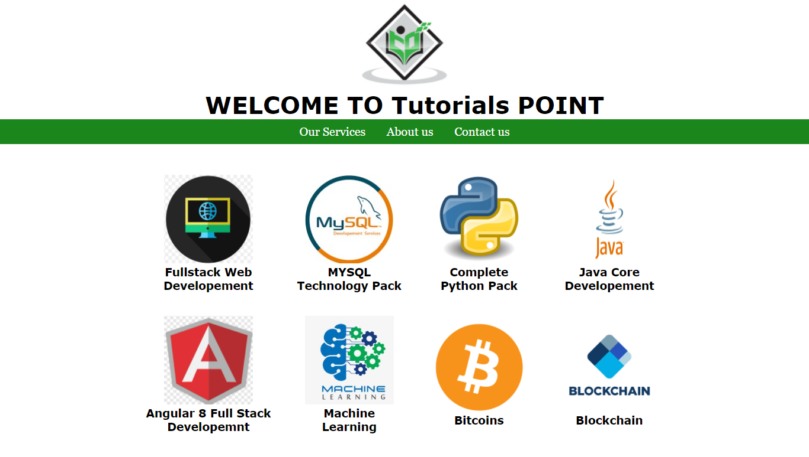

**About Page**

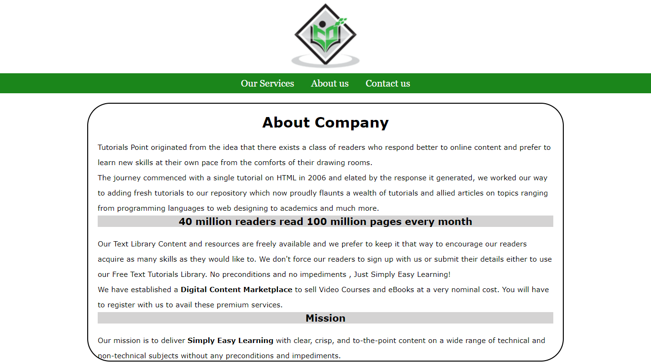

**Contact Page**

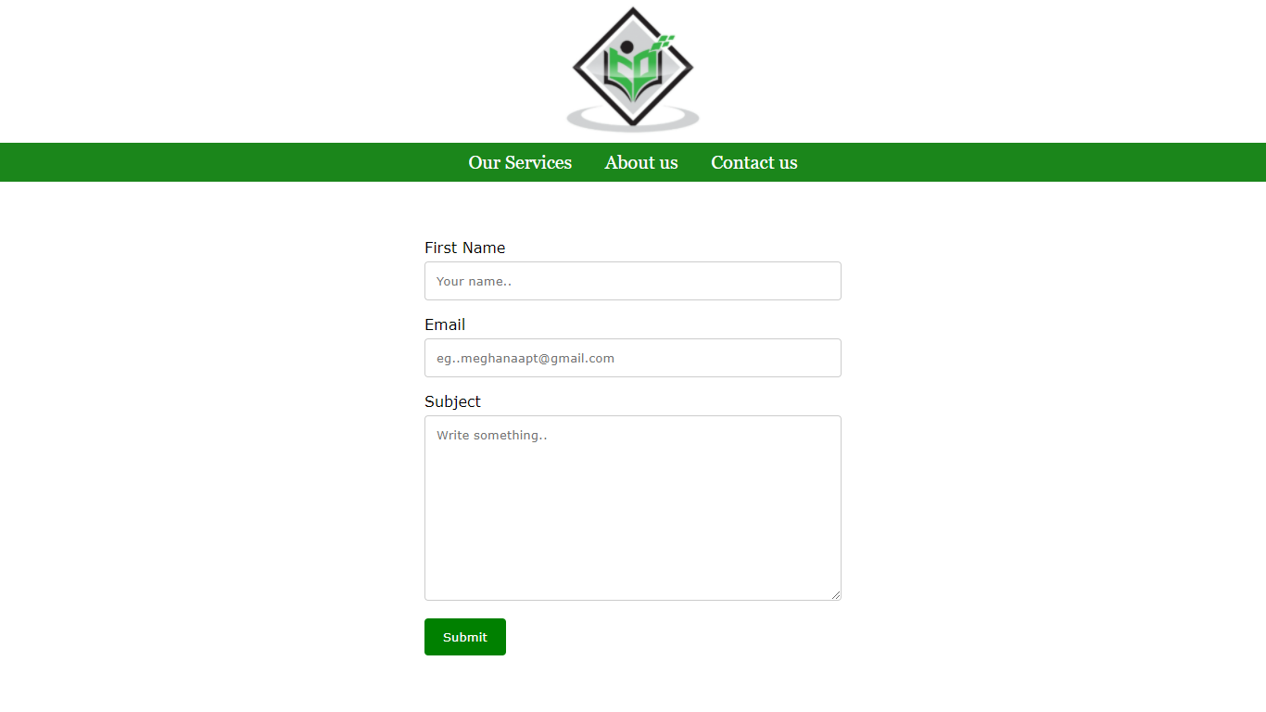

1. **Use table tag to format web page. Also create the Time Table of your class using**

**table tag.**

**Source Code:**

<!DOCTYPE>

<html>

<head><title>2nd Year Lateral Time table</title>

<style>

table{

background-color: yellow;

border: 1px solid black;

}

td,th{

border: 1px solid black;

}

</style>

</head>

<body>

<table>

<thead><tr>

<th colspan="10"><img src="SRKRlogo.png" alt="Logo" width="60px" height="60px" ></img><ins>DEPARTMENT OF COMPUTER SCIENCE AND ENGINEERING</ins></th></tr>

<tr><th colspan="10" style="background-color:#d8b4ed;">SRKR Engineering College (A) Chinna Amiram Bhimavaram - 534201</th></tr>

</thead>

<tr>

<td rowspan="2">2/4 CSE-D</td>

<td colspan="6">2021-22 1st Semister Time Table</td>

<td colspan="3">Room CAB-402</td>

</tr>

<tr>

<td>1</td>

<td>2</td>

<td>3</td>

<td>4</td>

<td rowspan="7" style="background-color:#a5f2e3;">lUNCH</td>

<td>5</td>

<td>6</td>

<td>7</td>

<td>8</td>

</tr>

<tr>

<td>MON</td>

<td colspan="2">OS</td>

<td>OOP</td>

<td>OOP</td>

<td>M-3</td>

<td>M-3</td>

<td>....</td>

<td>....</td>

</tr>

<tr>

<td>TUE</td>

<td colspan="3">PP LAB</td>

<td>....</td>

<td colspan="2">SE</td>

<td>ES</td>

<td>ES</td>

</tr>

<td>WED</td>

<td>SE</td>

<td>SE</td>

<td>PP</td>

<td>PP</td>

<td colspan="3">OOP LAB</td>

<td>....</td>

</tr>

<td>THU</td>

<td>PP</td>

<td>PP</td>

<td>M-3</td>

<td>M-3</td>

<td>OS</td>

<td>OS</td>

<td>EP</td>

<td>EO</td>

</tr>

<td>FRI</td>

<td colspan="3">OS LAB</td>

<td>....</td>

<td>OOP</td>

<td>OPP</td>

<td>....</td>

<td>....</td>

</tr>

<td>SAT</td>

<td colspan="3">D1&D2-SOC-1</td>

<td>....</td>

<td>....</td>

<td>....</td>

<td>....</td>

<td>....</td>

</tr>

</table>

</body>

</html>

**Output:**

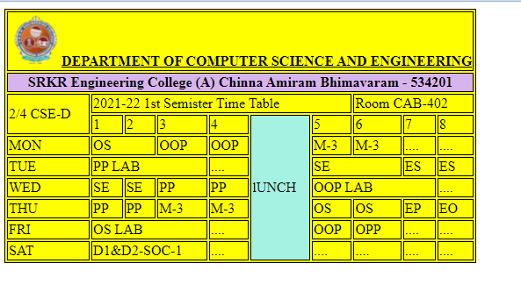

1. **Write an HTML code to create a login form. On submitting the form, the user should**

**get navigated to a profile page.**

**Source Code:**

<!DOCTYPE html>

<html lang="en">

<head>

<meta charset="UTF-8">

<meta http-equiv="X-UA-Compatible" content="IE=edge">

<meta name="viewport" content="width=device-width, initial-scale=1.0">

<title>Document</title>

<style>

.Field{

padding: 15px;

}

.Border{

border: 2px solid black;

width: fit-content;

height: fit-content;

padding: 6px;

}

</style>

</head>

<body>

<center><form action="Resume.html" class="Border">

<h3>Login</h3>

<div class="Field">

<label>Username</label>

<input type="email">

</div>

<div class="Field">

<label>Password</label>

<input type="password">

</div>

<div>

<input type="submit" value="Login">

</div>

</form></center>

</body>

</html>

**Output:**

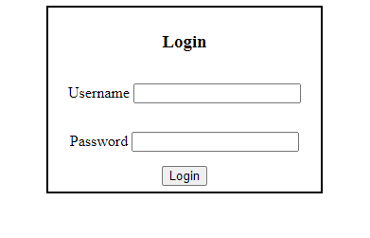

1. **Write an HTML code to create a Registration Form. On submitting the form, the user**

**should be asked to login with this new credentials.**

**Source Code:**

<!DOCTYPE html>

<html>

<head><title>Registration Form</title>

<style>

.border{

border: 2px solid white;

width:50%;

height:500px;

margin:auto;

padding: 10px;

}

input,textarea{

width: 100%;

height: 20px;

margin-top:5px;

}

input[type=radio]{

width:10%

}

</style>

</head>

<body>

<div class="border">

<form action="Login.html">

<fieldset>

<legend><h2>Register</h2></legend>

<table width="100%">

<colgroup>

<col span="1" style="width: 20%;">

<col span="1" style="width: 80%;">

</colgroup>

<tr>

<td>First Name</td>

<td><input type="text"></td>

</tr>

<tr>

<td>Middle Name</td>

<td><input type="text"></td>

</tr>

<tr>

<td>Last Name</td>

<td><input type="text"></td>

</tr>

<tr><td>Branch</td><td><input type="text"></td></tr>

<tr>

<td>Section</td>

<td colspan="1" width="50%"><input type="text"></td>

</tr>

<tr>

<td>Email</td><td><input type="Email"></td></tr>

<tr>

<td>Phone Number</td>

<td><input type="Tel"></td>

</tr>

<tr>

<td>Gender</td>

<td><input type="radio" >Male<input type="radio">Female</td></tr>

<tr><td>Date Of Birth</td><td><input type="date"></td></tr>

<tr><td>College Name</td><td><input type="text"></td></tr>

<tr><td>Address</td>

<td><textarea rows="4" cols="7" style="height: 140px;" ></textarea></td>

</tr>

<tr>

<td colspan="2"><center><input type="submit" value = "Register" style="width:100px"></center></td>

</tr>

</form></fieldset>

</div>

</body>

</html>

**Output:**

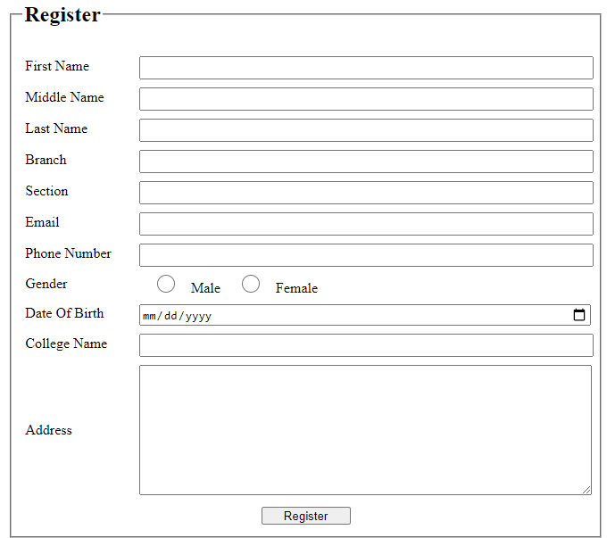

**7. Write an HTML code to create your Institute website, Department Website and Tutorial website for specific subject**

**Source Code:**

**Home Page:**

<html>

<head>

<title>Student Home Page </title>

<style>

button

{

background-color: #4CAF50; /* Green */

border: none;

border-radius: 3rem;

color: white;

padding: 15px 32px;

text-align: center;

text-decoration: none;

display: inline-block;

font-size: 16px;

margin: 4px 2px;

cursor: pointer;

}

</style>

</head>

<body background="login2.jpg" >

<br>

<br>

<center>

<div align="center"> <font face="Cambria" color="Red" size="5"><h1>Student Home Page</h1><font></div>

<table>

<br>

<br>

<tr>

<td>

<a href="Login.html"> <button>Sign In</button> </a>

<a href="Registrationform.html"> <button>Sign Up</button> </a>

</td>

</table>

</center>

</body>

</html>

**Main Page:**

<!DOCTYPE html>

<html>

<head>

<title>SRKREC</title>

</head>

<frameset rows = "20%,5%,*,10%">

<!--top with 20%-->

<frame name = "top" src ="wtop.html" />

<!--toolbar with 5%-->

<frame name = "toolbar" src ="wtoolbar.html" />

<!--middle with *%-->

<frameset cols = "15%,*,15%">

<frame name = "left" src = "wleft.html" />

<frame name = "middle" src = "wmiddle.html" />

<frame name = "right" src = "wright.html" />

</frameset>

<!--bottom with 10%-->

<frameset >

<frame name = "bottom" src = "wbottom.html" />

</frameset></frameset>

</html>

**Login Page:**

<!DOCTYPE html>

<html lang="en">

<head>

<meta charset="UTF-8">

<meta http-equiv="X-UA-Compatible" content="IE=edge">

<meta name="viewport" content="width=device-width, initial-scale=1.0">

<title>Document</title>

<style>

.Field{

padding: 15px;

}

.Border{

border: 2px solid black;

width: fit-content;

height: fit-content;

padding: 6px;

}

</style>

</head>

<body>

<center><form action="Resume.html" class="Border">

<h3>Login</h3>

<div class="Field">

<label>Username</label>

<input type="email">

</div>

<div class="Field">

<label>Password</label>

<input type="password">

</div>

<div>

<input type="submit" value="Login">

</div>

</form></center>

</body>

</html>

**Registration Page:**

<!DOCTYPE html>

<html>

<head><title>Registration Form</title>

<style>

.border{

border: 2px solid white;

width:50%;

height:500px;

margin:auto;

padding: 10px;

}

input,textarea{

width: 100%;

height: 20px;

margin-top:5px;

}

input[type=radio]{

width:10%

}

</style>

</head>

<body>

<div class="border">

<form action="Login.html">

<fieldset>

<legend><h2>Register</h2></legend>

<table width="100%">

<colgroup>

<col span="1" style="width: 20%;">

<col span="1" style="width: 80%;">

</colgroup>

<tr>

<td>First Name</td>

<td><input type="text"></td>

</tr>

<tr>

<td>Middle Name</td>

<td><input type="text"></td>

</tr>

<tr>

<td>Last Name</td>

<td><input type="text"></td>

</tr>

<tr><td>Branch</td><td><input type="text"></td></tr>

<tr>

<td>Section</td>

<td colspan="1" width="50%"><input type="text"></td>

</tr>

<tr>

<td>Email</td><td><input type="Email"></td></tr>

<tr>

<td>Phone Number</td>

<td><input type="Tel"></td>

</tr>

<tr>

<td>Gender</td>

<td><input type="radio" >Male<input type="radio">Female</td></tr>

<tr><td>Date Of Birth</td><td><input type="date"></td></tr>

<tr><td>College Name</td><td><input type="text"></td></tr>

<tr><td>Address</td>

<td><textarea rows="4" cols="7" style="height: 140px;" ></textarea></td>

</tr>

<tr>

<td colspan="2"><center><input type="submit" value = "Register" style="width:100px"></center></td>

</tr>

</form></fieldset>

</div>

</body>

</html>

**About Page:**

<!DOCTYPE html>

<html

<head>

<title>About Page</title>

</head>

<body align="center">

<p>Sagi Ramakrishnam Raju Engineering College (SRKR Engineering College), is a co-educational, independent and a private Engineering college. It was formed in the 1980s to provide a better quality technical education to students. The college is located on a 30 acres plot in Chinna-Amiram on the Bhimavaram - Juvvalapalem state highway, 2 miles from Bhimavaram town, that is well known as “Second Bardoli” and is famous for “Pancharamas” (Somaramam). It was founded in the year 1980 by donations from Sagi Rama Krishnam Raju.</p>

<p>The college was accorded permanent affiliation by Andhra University from 1987 for four-year degree courses. The college is presently affiliated to JNTU, Kakinada from 2017-18 admitted batch. The College was registered under the section 2 (f) of the UGC Act and it is eligible to receive central assistance under section 12 (b) of UGC. The College is recognized by the AICTE (All India Council for iTechnical Education) and the Institution of Engineers (India).</p>

<p>The College has a cluster of beautiful and spacious buildings with state of art laboratories, class rooms, seminar halls and play ground. Eco-friendly environment is developed in the campus with lot of greenery, landscape lawns and gardens. S.R.K.R. Engineering College was established with a mission to develop the college into a centre of Excellence in the field of Technical Education, capable of training students as sound professionals to cater to the needs of the society in the fields of production and service sectors.</p>

<img src="campus.jpg" width="700">

</body>

</html>

**Top Page:**

<!Doctype HTML>

<html>

<head>

<title>Top Page</title>

</head>

<body>

<table align="center">

<tr>

<td><img src="downloadss.png" height="100" width="700"></td> </img>

</tr>

</table>

</body>

</html>

**Toolbar Page:**

<!DOCTYPE html>

<html>

<body>

<center>

<table border=1 width=100% >

<tr align="center">

<td><a href="wmiddle.html" target="middle">Home</a></td>

<td><a href="http://www.srkrec.edu.in/intake.php" target="middle">Admissions</a></td>

<td><ahref="http://www.srkrec.edu.in/files/SYLLABUS/R20/CSE-R20-Syllabus.pdf" target="middle">Syllabus</a></td>

<td><a href="wabout.html" target="middle">About College</a></td>

</tr></table>

</center>

</body>

</html>

**Right Pane:**

<html>

<body>

<marquee behavior="scroll" direction="left"><a href=""> click here I-II Result are out...</a></marquee>

<marquee behavior="scroll" direction="left"><img src="fish-swimming.gif" width="94" height="88" alt="Swimming fish" /></marquee>

</body>

</html>

**Left Pane:**

<html>

<head>

<title></title>

</head>

<body align="left">

<h3>

<ul type="square">

<li><a href="http://www.srkrec.edu.in/intake.php" target="middle">Admissions</a></li>

<li><a href="http://www.srkrec.edu.in/files/SYLLABUS/R20/CSE-R20-Syllabus.pdf" target="middle">Syllabus</a> </li>

<li><a href="http://www.srkrexams.in/Login.aspx" target="middle">Result</a> </li>

<li><a href="Registrationform.html" target="middle">Registration Form</a> </li>

<li><a href="wabout.html" target="middle">About College</a> </li>

<li><a href="https://www.google.com/maps/embed?pb=!1m18!1m12!1m3!1d3824.6622013921196!2d81.49421901486477!3d16.543142788589645!2m3!1f0!2f0!3f0!3m2!1i1024!2i768!4f13.1!3m3!1m2!1s0x3a362d5e7ef94f99%3A0x3a2b78f9b48493fe!2sSRKR%20Engineering%20College!5e0!3m2!1sen!2sin!4v1637054984894!5m2!1sen!2sin" target="middle">College Map</a> </li>

</ul>

</h3>

</body>

</html>

**Middle Page:**

<!DOCTYPE html>

<html>

<head>

<title></title>

</head>

<body align="Center">

<h1>Hello Student</h1>

<h1>Welcome to SRKR Engineering College</h1>

</body>

</html>

**Bottom Page:**

<!DOCTYPE html>

<html>

<head>

</head>

<body align="top">

<center>

<h4>SOC LAB PRACTICE FOR E SECTION</h4>

</center>

</body>

</html>

**Output:**

**Home Page**

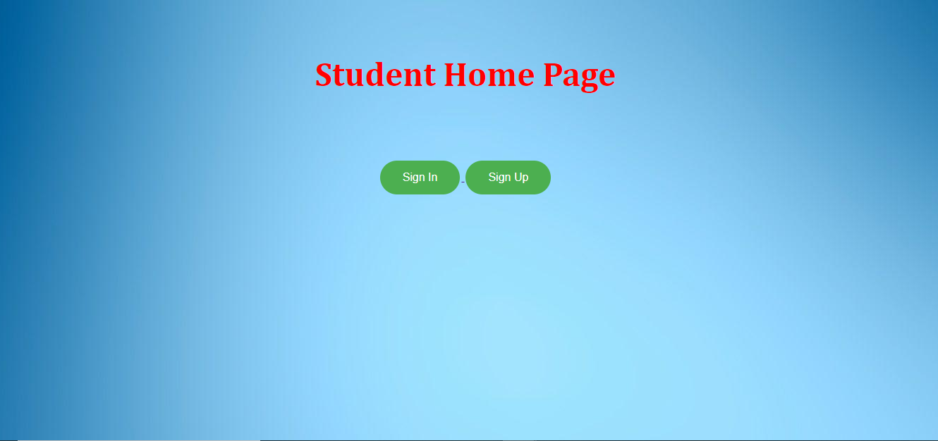

**Main Page**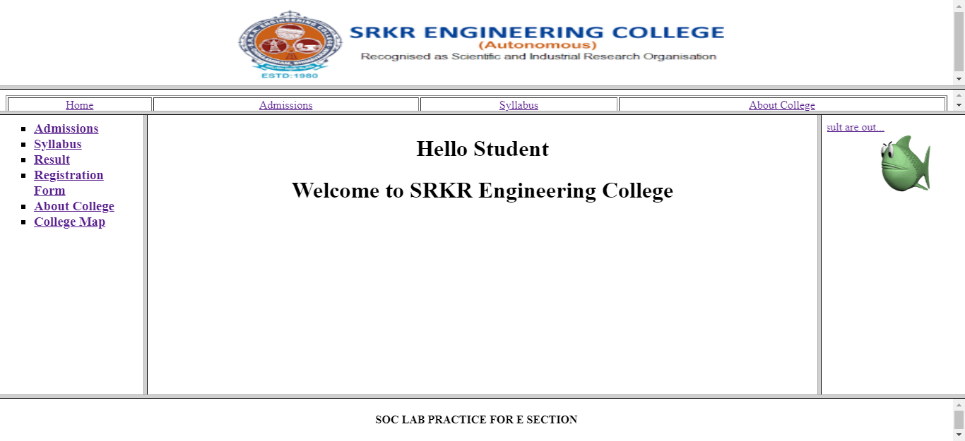

1. **Write an HTML code to demonstrate the usage of inline CSS.**

**Source Code:**

<!DOCTYPE html>

<html lang="en">

<head>

<meta charset="UTF-8">

<meta http-equiv="X-UA-Compatible" content="IE=edge">

<meta name="viewport" content="width=device-width, initial-scale=1.0">

<title>Document</title>

</head>

<body>

<div style="margin:20px auto">

<h1 style="color:red;font-size: 50px;font-weight: bolder;">Inline CSS</h1>

<p style="font-weight: bolder;font-size: 30px;">An internal style sheet may be used if one single HTML page has a unique style.<br/>

The internal style is defined inside the element, inside the head section.</p>

</div>

</body>

</html>

**Output:**

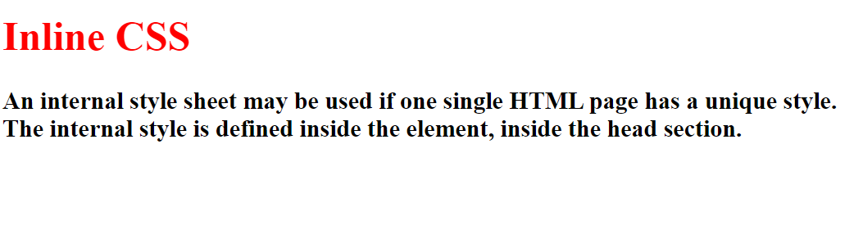

1. **Write an HTML code to demonstrate the usage of internal CSS.**

**Source Code:**

<!DOCTYPE html>

<html lang="en">

<head>

<meta charset="UTF-8">

<meta http-equiv="X-UA-Compatible" content="IE=edge">

<meta name="viewport" content="width=device-width, initial-scale=1.0">

<title>Document</title>

<style>

div{

margin:20px auto;

}

i{

color:blue;

text-decoration: underline;

}

h1{

color:red;

font-size: 50px;

font-weight: bolder;

}

p{

font-weight: bolder;

font-size: 30px;

}

</style>

</head>

<body>

<div>

<h1>Inline CSS</h1>

<p>The internal style sheet is used to add a unique style for a single document. It is defined in <i>head</i> section of the HTML page inside the <i>Style</i> tag.</p>

</div>

</body>

</html>

**Output:**

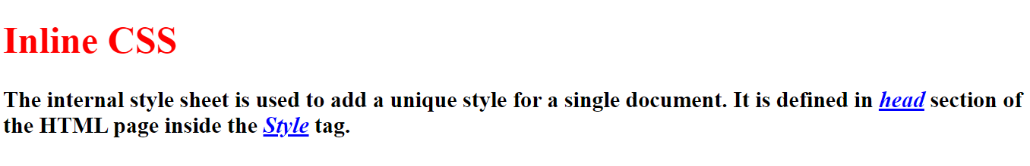

1. **Write an HTML code to demonstrate the usage of external CSS.**

**Source Code:**

<!DOCTYPE html>

<html lang="en">

<head>

<meta charset="UTF-8">

<meta http-equiv="X-UA-Compatible" content="IE=edge">

<meta name="viewport" content="width=device-width, initial-scale=1.0">

<title>Document</title>

<link rel="stylesheet" href="Externalstyle.css"></head>

<body><div>

<h1>External CSS</h1>

<p>The external style sheet is generally used when you want to make changes on multiple pages. It is ideal for this condition because it facilitates you to change the look of the entire web site by changing just one file.

It uses the <i>Link</i> tag on every pages and the <i>Link</i> tag should be put inside the head section.</p></div>

</body>

</html>

Externalstyle.css

div{

margin:20px auto;

}

i{

color:blue;

text-decoration: underline;

}

h1{

color:red;

font-size: 50px;

font-weight: bolder;

}

p{

font-weight: bolder;

font-size: 30px;

}

**Output:**

